XGS-5614S Unmanaged 10GbE Switch

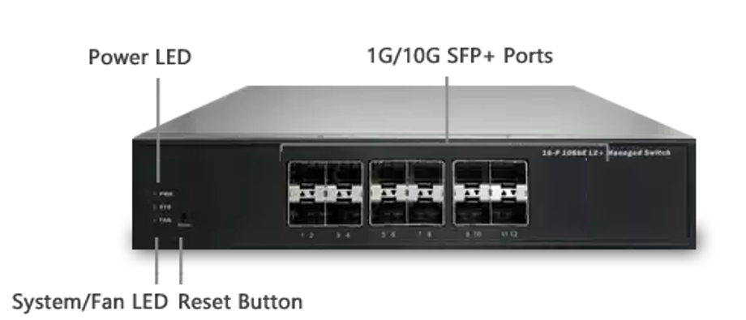
Overview
XGS-5614S Unmanaged Switch is a plug-and-play 10GbE Ethernet Switch product line offering 10G copper and fiber connections in a small form factor. With the enormous growth of network traffic and network storage in recent years, 10GbE is becoming a natural upgrade for many businesses in order to keep up with their network performance and business efficiency demands.
XGS-5614S delivers 14 GbE/10G SFP+ ports. It provides higher bandwidth and reliability for SMB and enterprise applications
It is ideal to provide combination of affordability and performance for entry-level networking in backbone applications and expands your enterprise network by adding local switching capacity for better scalability, so that you can support more high-bandwidth applications such as server farm, TV wall and digital signage video streaming, etc.
Key Features
- 8.6"-wide Small Form Factor Design
- All 10GbE Copper and Fiber Ports
- Auto-Negotiation for all Copper (100M/1G/10G) and Fiber(1G/10G) Ports
- Auto Fan Control for Better Reliability and Noise Reduction
- Plug-and-Play Installation with Zero Configuration
- Green Ethernet and Power Saving

Benefits
- Small Form Factor
Help you put the switch in locations that might not have sufficient room compared to other 10G switch which required larger space.
- 10GbE Interfaces
Provide superior network performance at non-blocking rate to delivers true 10GbE speed. 10GbE over CAT6a copper cabling up to 100 meters. SFP+ ports can be connected to other 10GbE ports with optical transceivers over multimode or singlemode fiber optic cabling.
Auto-negotiation senses and adjusts network speed and cabling type automatically.
- Easy to Install and Built with Affordable Ethernet Switch for SMB
It’s Plug-and-Play with zero configurations and no required ongoing administration. Build for Small and Medium Businesses provides 10G connectivity ports at a price that SMB customers can afford easily.
- Green Ethernet and Power Saving
Energy-saving capabilities save your money by lower power consumption. The smart fans feature can also reduce power consumption and noise at lower temperatures by utilizing different fan speeds for different temperatures.
Specifications
Port Configuration
Total Ports | Dominant Port |  | Uplink Port |  | Console
Total Ports | RJ45 100M/1G/10G | SFP+  1G/10G | RJ45  100M/1G/10G | SFP+  1G/10G | Console
14 | -- | 12 | -- | 2 | --

Hardware Performance
Forwarding Capacity | Switching Capacity | Mac Table | Jumbo Frames
208.32 Mpps | 280 Gbps | 16 K | 9216 Bytes

Environmental Range
Operating Temperature |  | Storage Temperature |  | Altitude
Fahrenheit | Centigrade | Fahrenheit | Centigrade | Feet | Meters
14 to 122 | -10 to 50 | -4 to 158 | -20 to 70 | < 10000 | < 3000

Dimension, Weights, Humidity
Dimension (WxHxD) |  |  | Weight |  |  | Operating Humidity
Millimeter | Inches |  | Kilograms | Pounds |  | Operating Humidity
220 x 44 x 242 | 8.66 x 1.73 x 9.5 | 1.9 |  |  | 4.19 | 10% to 90% non-condensing

Voltage/Frequency, Acoustic, and Compliance Information
FAN | Voltage/Frequency | Acoustic | Certification
2 | 100~240V / 50~60 Hz | < 42db at 25℃  (refer to ISO 7779) | CE, FCC Class A  Others by Request

